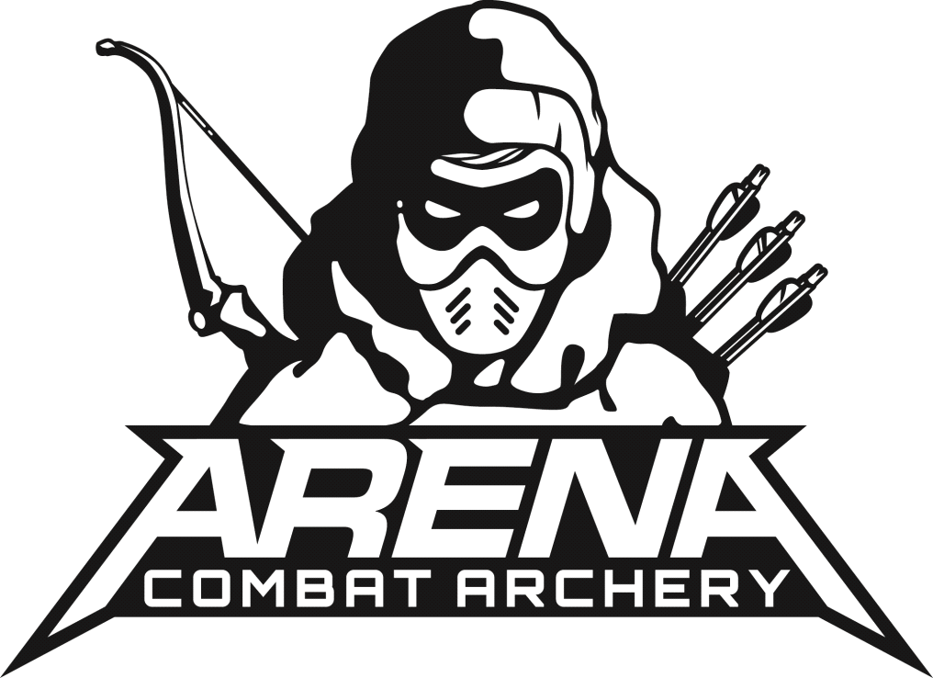
ARENA COMBAT ARCHERY LTD UNDER 16’s WAIVER
As a condition of The ARENA Combat Archery Ltd Insurance, you are required to inform your son/ daughter of the following rules and conditions as well as provide a signature to confirm that he/she understands the following conditions before playing:
I confirm that my son/ daughter fully understands the following rules: -
- Always listen to and follow the instructions of the Arena Combat Archery staff
- Masks must be worn at all times within the playing areas
- Never to shoot any arrows at players who are not wearing masks
- No shooting at another player in the safe zone or shoot whilst inside the safe zone.
- Always inspect every arrow that it is safe before shooting
- Do not ‘dry fire’ (pull bowstring back with no arrow inside)
- Do not deflect any arrows with your bow or run with your bow drawn
I confirm that my son/daughter will not participate if they: - Have any existing injuries - Have any medical condition that may adversely affect their ability to play - Are under the influence of drugs, alcohol or any medication that affects their ability to make decisions.
Each individual confirms and understand that
- I have agreed to participate in Combat Archery by Arena Combat Archery Ltd entirely at my own risk recognising that the ground can become slippery in certain weather conditions and that there are hazards in the playing environment.
- I am physically fit and mentally able to take the strain and exertion involved in playing the game.
- I will at all times comply with the rules set out by Arena Combat Archery Ltd.
- Wear the face protection issued and use equipment as instructed.
- I will obey all directions of all the Arena Staff
- I am fully aware of the risk to myself and others involved in playing the game, The possibility of injury to myself and others exist
- The game can be dangerous if not played in accordance with the stated rules in which i have fully read and understand. - I hereby release, remise and forever discharge from any claims and liabilities whatsoever without limitation that i might have against Arena Combat Archery Ltd, the staff at Arena Combat Archery Ltd and the owners of which the property is played on as well as any other player in the game who might injure my son/daughter howsoever arising and i make this release on behalf of myself, my heirs, executors, assigns and administrators.
By signing this Declaration & Waiver Form i acknowledge that i have read and understand the rules, have explained them clearly to my son/daughter, and fully understand the risks involved.

I give permission for my son/daughter to take part in Combat Archery sessions run by Arena Combat Archery Ltd. My son/daughter will agree to abide by the rules at all times as explained by the Staff, and will familiarise themselves with all safety equipment provided. All reasonable safety precautions will be undertaken by Arena Combat Archery and there is a zero tolerance policy given to participants who breach health and safety rules.

I shall instruct my son/daughter to abide by the safety instructions and behavioural requirements given by Arena Combat Archery Ltd Staff at all times. I accept that there is a possibility of accidents and injuries that may occur, however remote, and i hereby absolve Arena Combat Archery Ltd and their servants and agents from all liability in respect of personal injury, death, accident or damage to persons or property howsoever this may arise or be caused. The activity is undertaken entirely at their own risk.
By Signing this agreement you agree to Arena Combat Archery using media captured during the session for their marketing

Name of participant:
Date of Birth:
Parent/Guardian Details:
Phone Number:
Email Address:
Any disabilities, illnesses or other relevant information that Arena Combat Archery Ltd should be aware of?

Signed by Parent or Guardian:
Signed by Participant:
Date:

